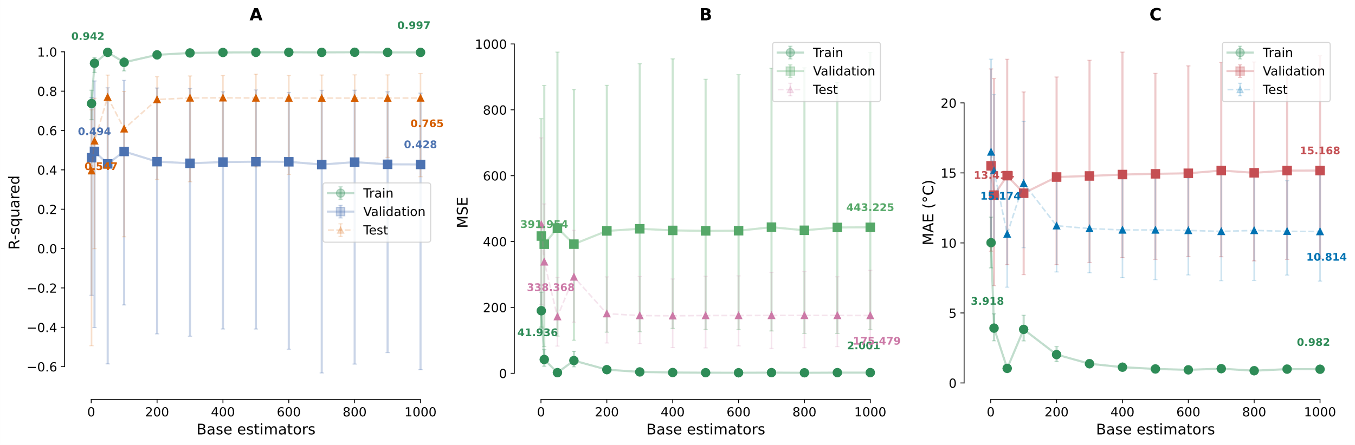
Figure 1 Ensemble performance with 95% bootstrap confidence intervals (n=1000) showing uncertainty in R², MSE, and MAE metrics across different estimator counts.

